**WWF /** [**http://www.wwfkorea.or.kr/**](http://www.wwfkorea.or.kr/)  
**주소: 서울 종로구 종로 47 SC제일은행본점빌딩 15층 (재)한국세계자연기금/ 25명**

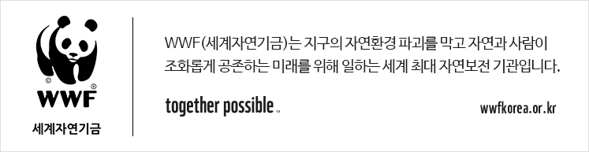  **[종각역] 비영리 자연보전기관 Admin Officer채용 공고  
  
[근무회사 및 모집부문]**  
**\* 근무회사: 종각역 부근에 위치한 자연보전기업 (WWF/한국세계자연기금)  
* 사업분야: 비영리단체/협회/교육재단  
* 모집분야: Admin Officer**

**\*비영리 국제단체 근무, 환경보전활동에 관심있으신 분들에게 좋은 기회입니다.  
*재무, 회계 전공 및 경력 있으신 분들 우대합니다.**

**[업무내용]**

**<Administration>**

-Maintain and update Company’s official documents such as contract, employee contact list and BOD contact list etc.

-Manage and purchase office supplies for office operation in line with FMO policies

-Coordinate business travel and support to issue required document

-Manage external service providers for the office operation and support for payment

-Manage office facility, real estate, cleaning, workplace and security

-Manage F&O part of checklist for new and retired employees

-Asset management

-General administration issues

**< IT >(Not mandatory)**

-Implement overall IT task

-Manage IT equipment and software purchase

-Communicate with internal & external service providers about IT issues.

-Manage inner server system(NAS) for office operation as per WWF global guidance

-Manage E-approval system’s smooth operation and recommend the improvement if any.

**<Finance>**

-Update actual vs budget and report to the functional director.

-Organize finance documents and deliver them to the accounting corp. for PRF & Monthly reports

-Assist with a variety of finance tasks

**[지원자격]**  
-English communication capability - reading, writing and speaking

-Proven ability to manage time and priorities conflicting tasks

-Excellent communication skills in interaction with internal and external stakeholders

-Minimum 1years’ experience in operations

**[우대사항]**

-Bachelor degree for the Business Administration or Accounting major.

-Certification for IT or Accounting

**[근무환경]**- 계약기간: 2개월 파견계약직(연장가능 / 업무 평가에 따라 정규직 전환 가능)- 근무지: 서울시 종로구 종로 **(3호선 종각역 부근)**- 근무시간: 09:00 ~ 18:00 **(주 5일 근무)  
- 급여: 경력직의 경우 경력 및 최종연봉에 따른 차등 지급  
- 복리후생: 4대보험, 연차, 퇴직금, 경조금, 생일 기프티콘, 경조휴가 등**

**[지원방법]**  
- 이메일 지원: lily.kwak@manpower.co.kr  
- 이메일 제목: 종각역 Admin _본인 성함 기재  
- 제출서류: 국문 이력서 및 자기소개서 (MS Word 양식)  
- 담당자: 곽나현, 02-2051-6676